**PROJECT DOCUMENT**

**SRS: Software Requirements Specification.**

For

# Bartering Books Website

**Prepared By**

**KARAN BHATT**

**201803100810008**

**KEVIN MEHTA**

## 201803100810074

**Department Of Information Technology Engineering, Chhotubhai Gopalbhai Patel**

**Institute of Technology, Uka Tarsadia University**

**06-09-2021**

**Problem Definition:**

Many individuals want to give away the books they no longer need. Traditionally, they can either talk to their friends or have to look for the people who are in need via different connections. These activities are time consuming and exhausting. So this problem can be resolved using this platform.

.

**Table of Contents**

### 1. Introduction. 3

(Basic information of project)

#### 1.1. Purpose. 3

(Intension Behind this project)

#### 1.2. Scope of Project. 3

(Project Goals, Deadlines, Cost)

#### 1.3. Intended Audience. 3

(Expected Users)

#### 1.4. Abstract 4

#### 1.5. References 4

### 2. Overall description. 5

(Functional and non-functional requirements)

(Hardware and Software Requirement)

#### 2.1 Product Perspective 5

2.1.1 Hardware Specifications **5**

2.1.2 Software Specifications **5**

#### 2.2 Product Functions 5

2.2.1 Functional Requirements **5**

2.2.2 Non-Functional Requirements **6**

2.2.3 Use Case Diagram **7**

2.2.4 Activity Diagram **7**

2.2.5 Data Flow Diagram **8**

2.2.6 Class Diagram **9**

## 1. Introduction

### 1.1 Purpose

As the name of the project suggests, the aim here is to create a platform for book lovers. The purpose behind this website is to provide a single platform to those users who are fond of reading books and connect book owners who are interested in trading their used books with other book owners' used books.

### 1.2 Scope of Project

This website will provide a way to buy cheaper books online and a better way to recycle textbooks. Users will be able to make money for themselves by selling second hand-books. It shall be easy to navigate, user-friendly, and easy to find books in various categories.

### 1.3 Intended Audience

The website hopes to have an audience who are in search of books. There are no restriction criteria for an audience as of now.

* An audience can be kids who are beginners or youngsters who already have fond of reading or who want to begin book reading.
* An audience can be a person who intends to sell his book or he/she can be a person who wants to explore and buy books provided on the website.

### 1.4 Abstract

Since books are among the major money-draining necessities, we want to implement a system to facilitate the trading of used books among people. They will log on to our site, enter the books they want to sell, the books they want to buy or even exchange, and, when there is a match, users can contact each other to complete the transaction.

]A user can exchange books or buy a used book for half the price, and, assuming the price of that book doesn’t change for a year, sell the same book back for the price that the student bought it for. This way, even though no one is “making money” and everyone benefits.

## 2. Overall Description

As the intention is clearly defined this section will describe the main software requirements and working.

**2.1 Product Perspective:**

2.1.1 **Hardware Specifications:**

* **Front-end** : Django, HTML, CSS, Javascript, Jquery
* **Back-end**: Django, PostgreSQL
* **Technology**: Django webserver
* **Operating System**: Windows XP, Windows 7/8//10, Ubuntu – Linux, Mac Os

2.1.2 **Software Specifications:**

* **Processor**: Dual-core i3 or more
* **RAM**: 2 GB
* **Hard Disk**: 10 GB

**2.2 Product Specification:**

2.2.1 **Functional Requirements**

|  |  |  |
| --- | --- | --- |
| NO. | TITLE | DESCRIPTION |
| 1) | **Signup** | New users will have to register to use the website. |
| 2) | **Login** | Registered users and admin will be able to log on to the website. |
| 3) | **Home** | On the homepage the general layout along with features such as filter, follow, post, DMs and many more will be offered. |
| 4) | **About** | On this page, the information regarding the website and their makers are provided. |
| 5) | **Contact** | User can contact via contact form or from social media links to us provided on this page |
| 6) | **User Dashboard** | Users will be able to see their profile, followers, and their posts. They can also update, delete their posts as well as certain information in this section. |
| 7) | **Admin Dashboard** | In this section, only the admin can enter and can remove users, posts, and unnecessary stuff across the website. |
| 8) | **Leader board** | This is a special section of the website where the list of the users with their points will be displayed. |
| 9)  10)  11)  12) | **Post**  **Search**  **Genre selection**  **Location** | User can upload, delete the post. Along with it they can save, like, comment on the posts in feed.  User will be able to search the books they want.  User is allowed to select the genre of the books and accordingly results will be displayed.  Feed based on location will be generated after selecting specific location. |

### 2.2.2 Non-Functional Requirements

|  |  |  |
| --- | --- | --- |
| NO. | TITLE | DESCRIPTION |
| 1) | **Security** | User credentials details are safe which comes from users or from cookies to the database. Prevents malware attacks. |
| 2) | **Performance** | The website will load smoothly and in a fast manner. |
| 3) | **Portability** | A website can be accessed from any computing device with the internet. |
| 4) | **Availability** | Website will be available 24x7 and in case of any failure of hardware; database corruption backups of the database should be retrieved from the server. |
| 5) | **Scalability** | If demands of these user increases website would be capable to handle it and remain stable. |
| 6) | **Reliability** | If any problem or situation arises then still site can run without failure of the system or elements. |
| 7) | **Regularity** | A website should be updated regularly to improve and give the user the best interface. |
| 8)  9) | **Storage**  **Access** | User Information is stored in a database so that it can be easily retrieved whenever needed.  Only authorized users can enter into the admin dashboard by proving his/her authentication using the correct username and password. |
| 10) | **Understandable** | The website interface should be less complex as it includes more categories so users can understand easily. |

2.2.3 **Use Case Diagram:**

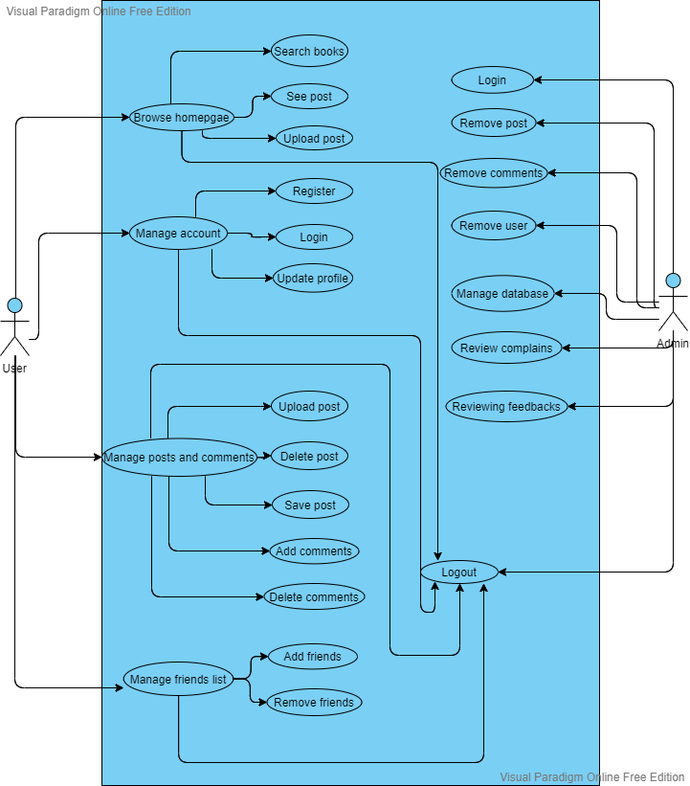

2.2.4 **The Behavioural view diagram - Activity Diagram:**

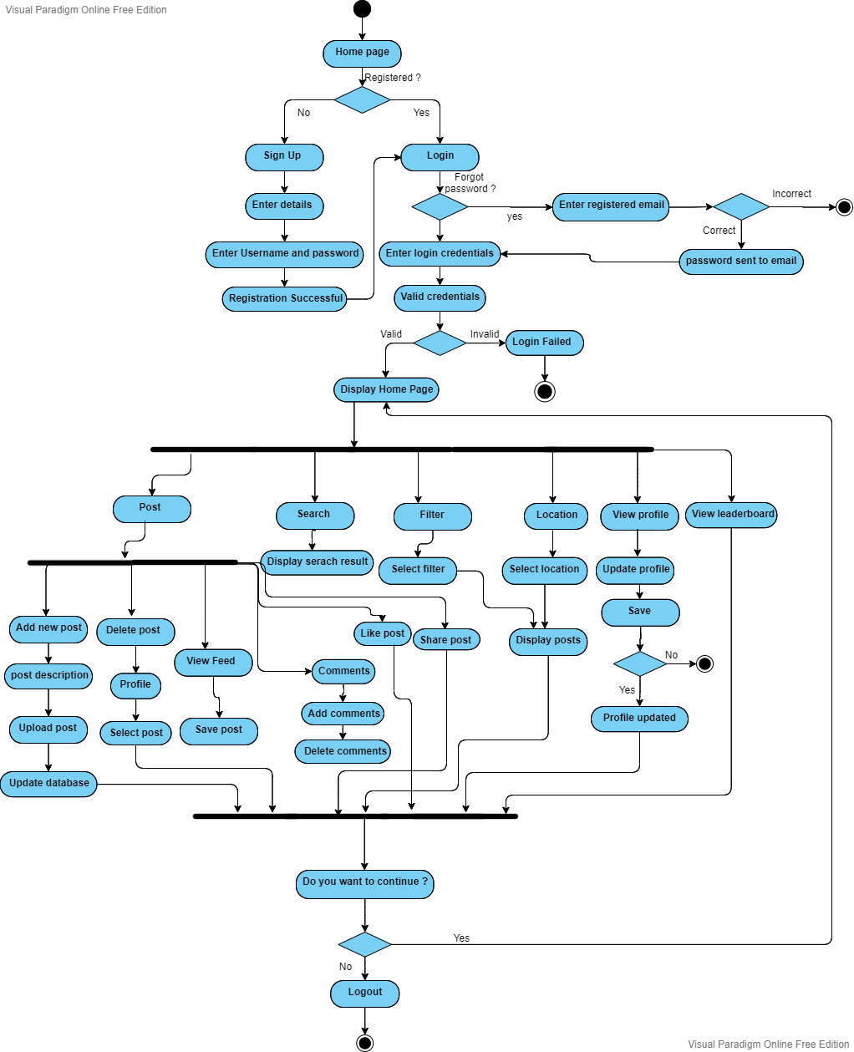

2.2.5 **DFD: Function Oriented Diagram:**

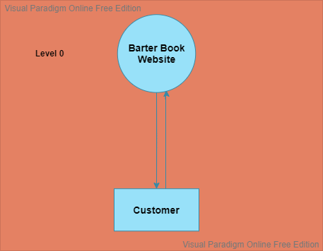

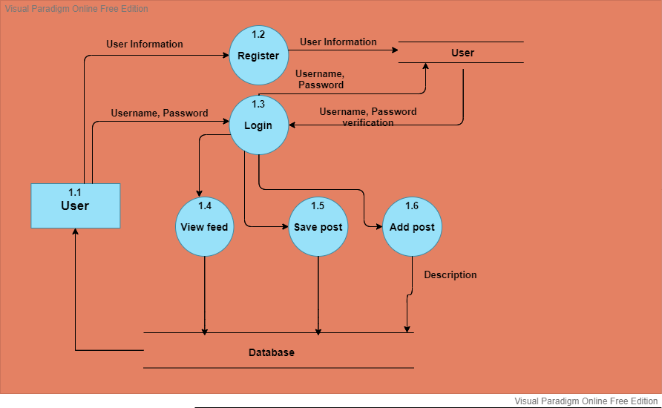

2.2.6 **The Structural view diagram: Class Diagram**

# https://miwamnhyon.us-05.visual-paradigm.com/rest/diagrams/projects/clipboard/1_nT5Ord6FYDwCG2uB?dummy=1D29rd6DySmqoQHY

**Sequence Diagram:**

